Name: Quang Huynh Yellowstone National Park/Wolves

Read article and watch video before answer the following questions:

**Questions:**

1. Define predator = A predator hunts other animals and prey.

2. Why were the gray wolves considered a nuisance predator? Gray wolves are considered a nuisance predator because they would kill livestock.

3. How were the following organisms affected by the removal of the wolves in Yellowstone National Park?

* Cottonwood and Aspen trees = Became to appear dry and barren
* Elk = Increased in population and became courageous.
* Beavers = The beavers had their food being destroyed, and their stream became too fast, which made them move to another habitat.
* Willows = Was eaten by the elk.

4. When and why were the wolves reintroduced into Yellowstone National Park?

In 1995, the gray wolves were reintroduced into Yellowstone National Park due to all of the factors and aftermaths of the gray wolves being removed. The wolves would help with population and bringing back animals.

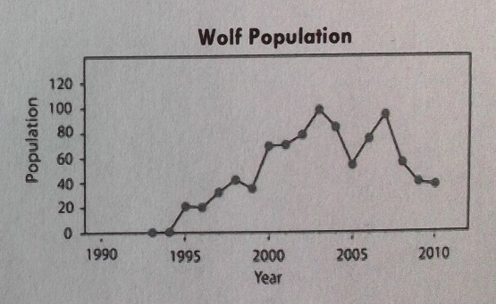Use the graphs below to answer questions 5-8.

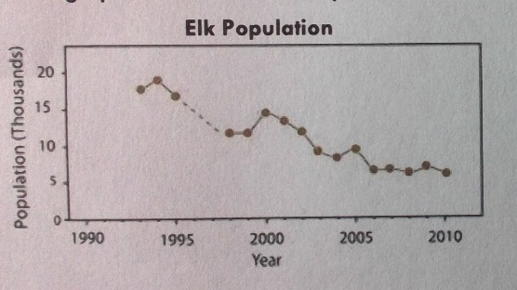

5. You have already identified that wolves are a predator of elk. Describe the general trend of the elk and wolf populations between 1993 and 2003.

The wolves increased in population, while the elk’s population had decreased.

6. Based on the graphs, what year do you think wolves were introduced to Yellowstone? Explain why you think this.

I would think the wolves were introduced to Yellowstone in 1995, as the population had rapidly gone up in that year.

7. Using information from the graphs, describe what happens to the wolf and elk populations in 2005. Indicate what you think might have happened during this year to cause this change.

In 2005, the removal of wolves contributed to the increase in population of the elk. The population may have been affected by the loss of food, a disaster, or people’s negative opinion on the wolves.

8. In 2010, the wolf population was lower than in previous years. Make a prediction about the elk population in the years beyond 2010 if the wolf population continues to stay at the 2010 level.

In the future, the elk population will start to increase if the wolves remain at a 2010 population level.